AFYA BORA CONSORTIUM GLOBAL HEALTH LEADERSHIP FELLOWSHIP PROGRAM
Research Methods
Distance Learning
PARTICIPANT GUIDE

AFYA BORA CONSORTIUM
Research Methods Module

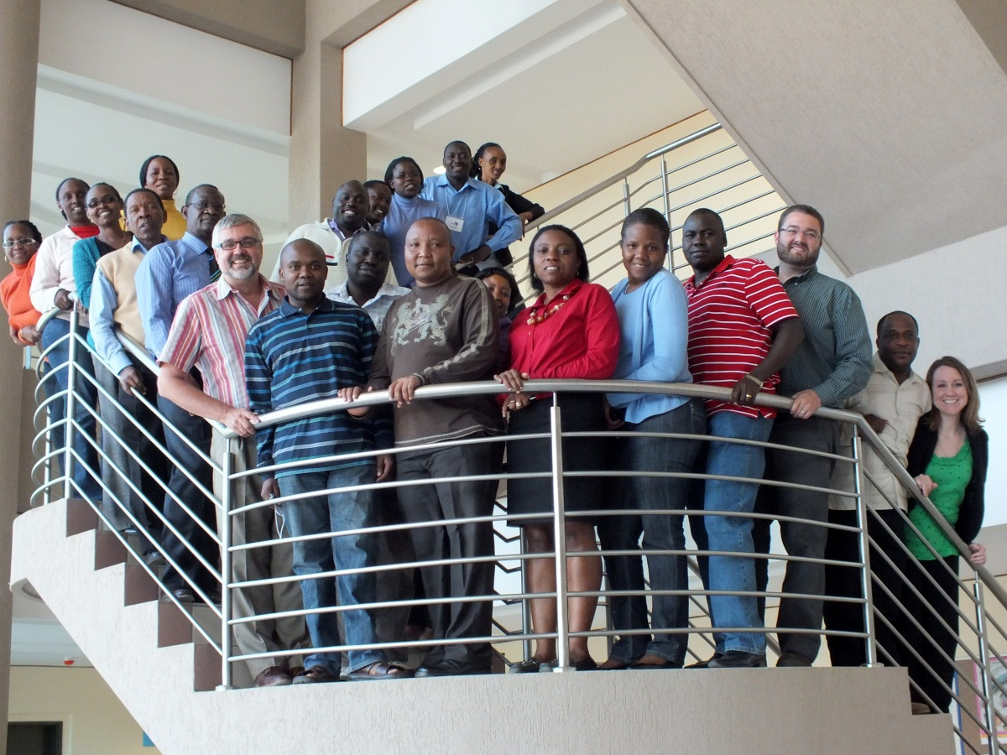

Module Instructors:

Brandon Guthrie, PhD
Acting Instructor, Department of Epidemiology
University of Washington
Email: bguth@uw.edu
Skype: brguth

Carey Farquhar, MD, MPH
Associate Professor, Departments of Medicine, Epidemiology, and Global Health
Director, Afya Bora Fellowship in Global Health Leadership
Email: cfarq@uw.edu
Skype: careyfarquhar

Course Structure:
To successfully complete the Research Methods module, you will need to watch each lecture and complete the associated quiz in accordance with the course schedule. Each recorded lecture is available online through the TREE Distance Learning portal (http://www.tree4health.org/distancelearning/). You will be assigned a username and password allowing you to log onto the portal. Once you are logged on, click on the Research Methods Module in the Learning Modules box. In the Research Methods Module, you can monitor your progress through the module and navigate between lectures. For each lecture, you can view the recorded session, download the session for later viewing, and download the slides and associated material. After viewing each lecture, students should complete the associated quize.

Course Instructors will be available via Skype bi-weekly (schedule TBD) to discuss each topic.

You are limited to 1 attempt on each quiz. If you achieve an aggregate average score of 70% or greater on the quizzes, you will be eligible to take the final exam.

The Research Methods consists of
- 10 one-hour lecture sessions,
- 10 quizzes, and
- 1 final exam.

Learning Objectives:

Introduction to Epidemiologic Methods and Quantitative Research
- Give an example of a disease that is distributed unevenly in a population and what the distribution might tell you about the cases of disease.
- Define prevalence and incidence and describe the steps to measure each in a typical epidemiologic study.
- Answer the question: How do you compare disease risk between two groups and how do you interpret these comparisons?
- Summarize the principles for inferring causal relationships from epidemiologic data.

Introduction to Statistical Decision Making
- List and describe the standard measures of location and spread.
- Give examples of how graphical displays of data can be used to supplement formal statistical analysis.
- Understand the relationship of hypothesis testing and independence of data.
- Answer the question: What is a p-value and how are they used to assess the strength of statistical associations?

Epidemiologic Study Designs
- Compare and contrast cohort and case control studies and provide examples of when each study design would be appropriate and preferred.
- Answer the question: What are the advantages and disadvantages of matching in epidemiologic studies?
- Answer the question: What are the primary strengths and weaknesses of randomized trials?
- Answer the question: How do ecological studies differ from the other types of epidemiologic studies?

Causation, Bias, and Confounding
- List the criteria that allow epidemiologists to assess causal relationships between exposure and disease
- Define bias in epidemiologic studies and describe the main categories of bias.
- Describe the most common strategies to controlling for confounding.

Measurement, Classification, and Misclassification
- Given an example of how the research question of interest will dictate how subjects are classified in terms of exposure and disease.
- Compare and contrast the impacts of non-differential and differential (selective) misclassification.
- Define and describe how to calculate sensitivity, specificity, positive predictive value, and negative predictive value.

Data Management Practices in Health Research
- Describe how study design will influence data management strategies.
- Give examples of data entry techniques that minimize errors.
- Outline quality control measures that can improve data quality.

Interpretation of Epidemiologic Studies and Decision Making
- Understand how to interpret the various measures of test performance;
- Explain how evidence from observational studies can be used to infer causal relations between exposures and disease incidence;
- Describe the criteria that should be used when deciding if a screening test should be used to detect disease.

Qualitative Research Methods
- Define phenomenology and grounded theory methods and provide examples of how these methods can be used to address a public health question.
- Provide a data collection strategy that could be used in a qualitative research study.
- Compare and contrast quantitative a qualitative research methods.

Analyzing Qualitative Data and Public Health Applications
- Provide strategies for managing qualitative data.
- Define coding and differentiate between types of codes.
- Illustrate how qualitative data is presented in a paper.

Course Schedule:
 | Lecture | Quiz Due Date | *Skype Session Group 1 | Skype Session Group 2
1 | Introduction to Epidemiologic Methods and Quantitative Research
2 | Introduction to Statistical Decision Making
3 | Epidemiologic Study Designs
4 | Causation, Bias, and Confounding
5 | Measurement, Classification, and Misclassification
6 | Data Management Practices in Health Research
7 | Interpretation of Epidemiologic Studies and Decision Making
8 | Multiple variable regression models in epidemiology
9 | Qualitative Research Methods
10 | Analyzing Qualitative Data and Public Health Applications
 | FINAL EXAM DUE

*Course instructors will be available via Skype bi-weekly on Tuesday @ 9:00AM PST/ 8:00PM EAT. See group assignments on table below

Skype Group Assignments
Group 1 | Group 2

Appendix 1: List of Lecturers

Carey Farquhar, MD, MPH  Associate Professor  Departments of Medicine, Epidemiology, and Global Health  cfarq@uw.edu  Lecture 1 | Barbra Richardson, PhD  Research Professor  University of Washington,  Department of Biostatistics  barbrar@uw.edu  Lecture 2
Lisa Manhart, PhD
Associate Professor
University of Washington
Departments of Epidemiology and Global Health
lmanhart@uw.edu
Lecture 3

Brandon Guthrie, PhD  Acting Instructor  University of Washington  Department of Global Health  brguh@uw.edu  Lecture 4, 5 and 6 | Noel Weiss, MD, DrPH  Professor  University of Washington  Department of Epidemiology  nweiss@uw.edu  Lecture 7
Romel Mackelprang, PhD  Senior Fellow  University of Washington  Department of Global Health  romelm@uw.edu  Lecture 8 | Michele Andrasik, PhD  Acting Assistant Professor  University of Washington  Department of Psychiatry and Behavioral Science  mandrasik@fhcrc.org  Lecture 9
Kate Murray, MPH
University of Washington, Center for AIDS Research
krmurray@u.washington.edu
Lecture 10

