AFYA BORA CONSORTIUM GLOBAL HEALTH LEADERSHIP FELLOWSHIP PROGRAM
HEALTH INFORMATICS MODULE

Instructors: Sherrilynne Fuller, Ph.D., and Sam Kang’a, MSc

AFYA BORA CONSORTIUM
HEALTH INFORMATICS MODULE
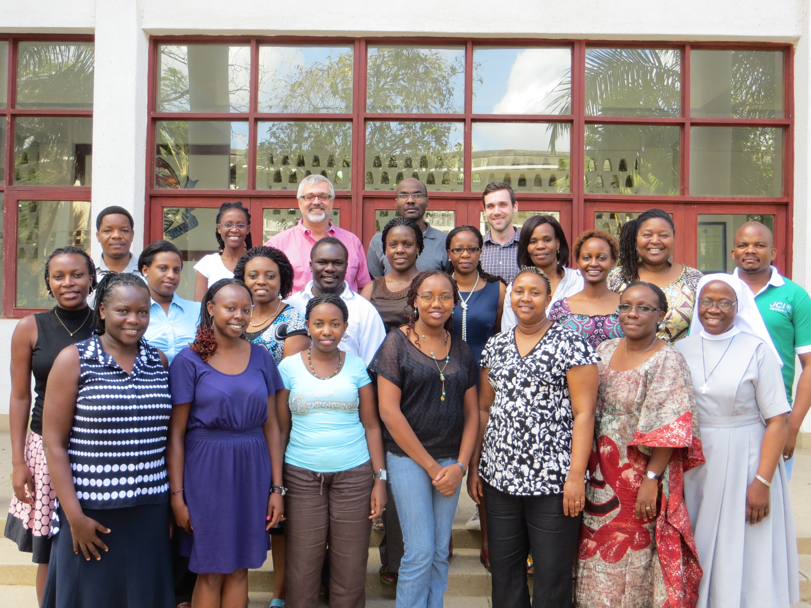
Guide for Fellows and Instructors
Module Instructors:
Sherrilynne Fuller, Ph.D.  Professor | Department of Biomedical Informatics  School of Medicine and  Department of Health Services (Adj)  School of Public Health and  Information School  Co-Director, Center for Public Health Informatics  Email: sfuller@uw.edu
Sam Kang’a, MSc | International Technical & Education Center for Health (I-TECH) Kenya  Rose Avenue Off Argwings Kodhek Road, Hurlingham,  Office: +254 20 2609340,  email: samkanga@gmail.com

Table of Contents
Introduction 4
Health Informatics Module --- Learning Objectives and Schedule 6
Learning Objectives: 6
Session Topics: 6
MODULE SCHEDULE: Health Informatics 7
Appendix 1. 12
The Karibuni Comprehensive Health Clinic: The Information Management Challenge 12
Teaching Purposes/Objectives 12
The Story 12
Figure 1: Organizational Chart of The Medical Facility 13
Table 1: Availability and mix of medical human resources 14
Discussion Points to Cover 19
Readings and Resources 20
NOTES 21

Afya Bora Consortium Fellowship in Global Health
Health Informatics Concepts and Principles Module
University of Nairobi
Nairobi Kenya
Dates: January 19-23, 2015

Introduction

Information lies at the heart of effective evidence-based health decision-making – throughout the health system. At every level – local, district, county, national and international – health workers require information and data for decision making and they create data and information for use by others.
Just as information and communications technologies (ICT) are transforming the lives of individuals in Africa and across the world there is a growing recognition of the potential of ICT to support and, indeed, transform the delivery of quality health care services.
Health informatics is an academic domain at the intersection of information science, computer science, and health care. It deals with the resources, devices, and methods required to optimize the acquisition, storage, retrieval, and use of information in health and biomedicine. Health informatics tools include not only computers but also information and communication systems.
E-Health is the commonly applied term for the application of ICT in the health sector. According to the World Health Organization (WHO), eHealth is defined as the cost-effective and secure use of Information and Communications Technologies (ICT) in support of health and health-related fields, including health-care services, health surveillance, health literature, and health education, knowledge and research. The definition introduces a range of services such as electronic health records to ensure continuity of patient care across time, mobile health services (mHealth), telemedicine, health research, consumer health informatics to support individuals in health decision-making, and e-learning by health workers. In practical terms, eHealth is a means of ensuring that the right health information is provided to the right person at the right place and time in a secure, electronic form for the purpose of optimizing the quality and efficiency of health care delivery and disease prevention programs.
Currently, members of the health workforce often lack knowledge and skills in key informatics competencies, including the ability to find, evaluate, manage and apply information and data to quality decision-making. This lack of knowledge and skills leads to poorly-designed information systems that frequently do not meet their intended needs, do not allow for sharing of information among systems in organizations, and results in barriers to sharing data and information with health information systems outside the organization.
Health workers and healthcare leaders need an understanding and awareness of how to identify, evaluate and apply data and information for quality decision-making. They must also appreciate how to adapt their health programs to take advantage of the benefits of these new information and communications technologies for improving the quality and speed of information and data sharing. Technical specialists are needed who can help define health worker information needs, acquire, and implement new information and communications systems, and assure that they produce information and data that positively impacts health.
The purpose of this week-long course is to provide participants with an understanding of the principles of health informatics and strategies for finding, evaluating and using health information and data as well as designing health information systems and tools for quality decision-making.

Health Informatics Module --- Learning Objectives and Schedule

Learning Objectives:

Fellows will be able to:
- Describe organizational factors affecting uptake and utilization of health informatics
- Understand and apply the principles and state-of-the-art developments in health informatics
- Evaluate the application and use of health information tools, resources and technologies in health systems
- Describe strategies for improving quality of health data
- Describe the legal, social, ethical and professional obligations in managing health information systems and resources
- Understand fundamentals of distance teaching methods and technologies in training and health workforce development

Session Topics:
- Health informatics definition and applications
- Organizational and environmental contexts of health informatics
- Evidence-based public health
- Data collection, management and sharing
- Electronic health record (EHR) systems; data migration process from paper-based records to EHR
- Disease surveillance systems
- Health information systems interoperability and the role of standards
- Privacy, confidentiality and security issues in health information systems
- Distance teaching strategies and technologies

MODULE SCHEDULE: Health Informatics

Day 1
Time | Activity | Presenters
8:30- 9:00 am | Registration
9:00 -9:30 am | Welcome and Introductions:  Prior Experience with ICT in Healthcare?  Learning Expectations? | Fuller, Kang’a
9:30-10:30 | Introduction to Public Health and Medical Informatics: Health Information Systems Concepts, Principles and Evidence-Based Practice | Fuller
10:30 - 10:45 am | Break
10.45 – 12:00pm | Understanding the Organizational and Environmental Contexts of Health Informatics | Kang’a
12.00 - 1.30 pm | Lunch
1.30 – 3:00 pm | Electronic Medical Record Systems; Data Migration from Paper to EHR– Strategies, Best Practices, Tools/Technologies for Digitization |  | Kang’a
3.00 - 3.15 pm | Break
3.15 – 5:00 pm | Online experience: OpenMRS and Kenya EMR; demo and hands-on practice  ASSIGNMENT: Read Karibuni Clinic Case and be prepared to discuss in groups on Tuesday |  | Kang’a

Day 2
Time | Activity | Presenter
9:00 - 10:30 am | Data Collection, Management and Reporting: Approaches and Technologies | Kang’a
10:30 - 10:45 pm | Break
10:45 - 12:00 pm | Introduction to Case Study: Karibuni Clinic: Group Assignments  Learning Objective: Practical problem – solving in data collection, management and reporting) | Fuller
12:00 - 1:30 pm | Lunch Break
1:30 - 3:15 pm | Karibuni Clinic Case – Analysis and Problem Solving: Assigned questions at end of case. | Team Work
3.15 - 3.30 pm | Break
3.30 – 5:00 pm | Karibuni Clinic Case – Analysis and Problem Solving | Team Work and Presentations

Day 3
Time | Title | Presenter(s)
9:00 - 9:30 am | Karibuni Clinic Case --- Lessons Learned | All
9:30-10:30 | Reducing Data Redundancy: Collect Data Once/Use Many Times | Fuller
10:30 - 10:45 am | Break
10:45 - 12:00 pm | Disease Surveillance Systems: Concepts and Strategies and Tools | Fuller
12:00 - 1:30 pm | Lunch Break
1:30 –2:30 pm | Explore surveillance tools and technologies MAGPI, EPIINFO, DHIS others) | Demos - Kang’a, Fuller
2:30- 3:00 pm | Travel to Kenyatta National Hospital: Understanding data collection and reporting in clinical settings  Class will be broken into small groups and each group will be assigned questions to investigate and report on.
3:00 – 5:00 pm | Understanding Data Collection and Reporting in Clinical Setting | Site visit -- Leader: Kang’a

Day 4
Time | Title | Presenter
9:00 - 10:30 am | Site Visit Findings Discussion:  Group Reports  Lessons Learned | Class Discussion
10:30 - 10:45 am | Break
10:45 - 12:00 am | Ehealth and Mhealth Technologies; Best Practices | Fuller, Kang’a
12:00 - 1:30 pm | Lunch Break
1:30 - 3:15 am | Distance Teaching and Learning Resources and Technologies: Best Practices (Skype, Moodle, Wikis, Google docs, Dropbox) | Fuller
3:15 - 3:30 pm | Break
3:30 – 5:00 pm | Online Work -- Explore and Utilize Distance Learning Technologies | Group Work

Day 5
Time | Title | Presenter(s)
9:00 - 10:30 am | Health Information Systems (HIS) Standards and Planning National HIS: Importance and Approaches | Fuller
10:30 - 10:45 am | Break
10:45 - 12:00 am | Privacy, Confidentiality and Ethical Stewardship of Resources; | Fuller
12:00 - 1:30 pm | Lunch Break
1:30 - 3:00 am | Review: Lessons Learned | ALL
3:00 - 3:15 pm | Break
3:15 – 4:00 | Farewells, and Course Evaluation | ALL

Appendix 1.

The Karibuni Comprehensive Health Clinic: The Information Management Challenge

Teaching Purposes/Objectives:
- Sizing up the environment, the institution and the stakeholders and the leaders
- What is evidence-based practice?
- Developing a plan; prioritizing
- Change management: challenges and approaches
- Interoperability of health information systems: collect data once; use many times
- Leadership from above and within
- Dealing with social/political/cultural/economic dimensions
- Evaluating outcomes -- the challenge of unintended consequences

The Story
You have just accepted a new position as Health Data and Information Systems Manager with responsibility for planning a new and comprehensive health information system for the Karibuni Comprehensive Care Center. You will be reporting to the Hospital Director, Dr. Awakame, a physician with many years of experience treating patients and managing health facilities in Sub-Saharan Africa. Dr. Awakame, himself does not use computers but the Board of the NGO that supports the facilities has directed him to create this new position and to develop a comprehensive health information systems plan for facilities management, patient care management and for reporting to the district and, to the NGO. The Board is very committed to evidence-based practice and Dr. Awakame is as well.
The Karibuni Comprehensive Care Center is a tier 4 health facility that is owned and supported by a community based NGO. Its mission is to provide innovative and consistently high quality, low cost healthcare in the safest possible way. It was started in 1979 as a Family Planning Clinic. In the early 1980s it ran vertical clinics of Family Planning (FP), Antenatal Care (ANC) and Baby Clinic. It started integrating these services gradually and in 1992 there was one clinic called the Maternal and Child Health/Family Planning (MCH/FP). In 1994 it added HIV/AIDS services and became MCH/FP /HIV/AIDS and added TB in 1995 to become MCH/FP /HIV/AIDS /TB. By 2004 this facility was running a fully-fledged and well integrated CCC offering Prevention of Mother-to-Child Transmission (PMCT), HIV/AIDS, TB, FP, Exposed Baby Programme and STI/drug addiction. There are two satellite clinics. The growth of the Karibuni Health Clinic has necessitated restructuring into departments and sections with three main program areas: that is Clinical, Specialized Programs and Administration/Finance as seen in Figure 1 below.
Figure 1: Organizational Chart of The Medical Facility

Karabuni Clinic has a catchment population of approximately 43,816 most of them poor urbanites. Daily outpatient visits: 175 adults and 75 children a day.
The total employees currently is 176 broken down as shown in Table 1,

Table 1: Availability and mix of medical human resources
# | Description | No Expected | No. Available | Deficit/surplus
1 | Consultants (MD) |  | 4
2 | Medical Officers |  | 8
3 | Dentists |  | 0
4 | Dental Technologists |  | 0
5 | Community Oral Health Officers |  | 0
6 | Clinical Officer (Spec) |  | 1
7 | Clinical Officers (Gen.) |  | 8
8 | Nursing officers |  | 0
9 | KRCHNs (Kenya Registered Community Health Nurses) |  | 17
10 | KECHNs (Kenya Enrolled Community Health Nurses) |  | 14
11 | Public Health Officers |  | 0
12 | Public Health Technicians |  | 0
13 | Pharmacists |  | 2
14 | Pharm. Technologist |  | 8
15 | Lab. Technologist |  | 9
16 | Lab. Technician |  | 2
17 | Orthopaedic technologists |  | 0
18 | Nutritionists |  | 5
19 | Radiographers |  | 2
20 | Physiotherapists |  | 0
21 | Occupational Therapists |  | 0
22 | Plaster Technicians |  | 0
23 | Health Record & Information Officers |  | 3
24 | Health Record & Information Technicians |  | 1
25 | Trained Community Health Workers |  | 10
26 | Social health workers |  | 1
27 | Community health extension workers |  | 37
28 | Medical engineering technologist |  | 3
29 | Medical engineering technicians |  | 1
30 | Total non-medical staff/ support staff |  | 40

The facility is situated in the periphery of a mid-sized Kenyan city where most of the population around it consists of the urban poor who are engaged in small informal businesses which might be netting a profit of about 2 dollars (US) a day.
According to the Program/Medical Director, Dr. Wawira, the main challenge is funding. The funding challenge is two pronged in that are not enough funds on one hand and the funds that available are mostly from donors who give strict conditions on use of the funds. This ties the facility administrators to using the funds exclusively in areas of interest to the donor. These areas may not necessarily be of priority based on needs of the patients and the staff. For instance, the donors have, in the past, denied repeated requests to fund planning, development and implementation of an electronic health record.
Dr. Wawira also added that another of the challenges lies in the initial mission statement of the facility which has since remained the same. The mission binds the facility to offer services at no or little fee to the recipients and thus it cannot raise funds internally even in cases where there is a necessity and the recipients are willing and able to pay. Dr. Wawira also cited the location of the facility as a challenge. The facility is located approximately 15km outside the city and surrounded by slums and villages. As a result of the location and the economic conditions of the population in the catchment area the facility must offer a courtesy bus to and from the facility.
The facility does not have enough personnel and in some areas none exist at all as shown in Table 1 above. This causes a strain in service delivery. This is quite evident from the queues in the waiting areas especially during times of malaria and cholera outbreaks. The facility is also lacking in adequate in-patient facilities.
Other challenges identified include following up on defaulting and migrating patients on ART. According to the pharmacy head, Mr. Atiwoto, this may be mainly due to poverty, illiteracy/ignorance about the necessity of taking drugs on the prescribed schedule and the fact that other facilities around the area are offering ‘better’ incentives for compliance such as food rations and education equipment for patients/clients children to encourage remaining on ART regimen.
According to the lead Health Record and Information Officer, Ms. Njiri, the facility uses the standardized MOH and National AIDS/STD Control Program (NASCOP) tools of collecting data, keeping records and reporting such as MOH 711 Report, MOH 257, Pre ART Register, and ART Register. In addition it uses Health Management Information System (HMIS) software that was developed by U.S, Agency for International Development (USAID) together with the AIDS, Population and Health Integrated Assistance (APHIA Plus through International Centre for Reproductive Health (ICRH). The MOH 257 is filled by nurses and clinicians when attending to patients. Later on these hard copies will be transferred into summarized MOH 711A by data clerks. This summarized sheet is sent to the District Health Records Information Officer (DHRIO) as hard copies or soft copies using FTP. The DHRIO later sends a copy to Provincial Health Records Information Officer (PHRIO). Other stakeholders can get the information at whatever appropriate stage but getting the information back into the hands of clinical staff at Karibuni in a timely fashion simply is not happening.
Thus the key challenge is the USAID/APHIA II HMIS tool cannot be effectively queried to give reports. It either takes too long to answer some queries (approx. 20 hours) or fails to answer the clinical question at all. This is frustrating to everyone involved especially the data clerks who have spent many tedious hours entering the data since there is no access to the data gathered and whenever reports are needed one must go back to the manual registers. This means that clinicians and data managers have no access to information about patients. In addition hospital services managers (Labs, Pharmacy, and the facility director) are unable to chart trends (for example, looking at incidence of malaria or cholera outbreaks over time so as to predict when there may be outbreaks which would allow stocking up on additional medications or hiring additional staff. Also, this HMIS accepts wrong data types in certain fields and therefore some obvious mistakes done at the data entry cannot be easily detected or prevented.
Clinicians are anxious to have access to up to date patient information (drugs, lab values, prior visits and diagnoses, immunizations and family-related information) so that time is not wasted when they see their patients. Currently clinicians have no information about patients they see and must depend on the notebooks with patient and consultation outcome summaries which are kept by the patient and supposed to be brought to each visit. However, this is rarely done. For this reason, the clinicians would like to have the files maintained at the clinic and brought to them from the records office for reference during the next visit. The staff at the records office is overwhelmed and can rarely locate the appropriate file before appointments commences (and usual the patient doesn’t have their notebook with them). Thus there is a lack of patient information except for the current complaints reported by the patient. And, the patient must buy a notebook at each visit (if they don’t bring it with them). The managers of the hospital see this recurrent purchase as income generation because when many patients buy notebooks, the hospital generates revenue. For out-patients, many people wait until market days to come to the clinic so they can make one trip do multiple things. Of course, there are many wares to carry to the market so they cannot easily remember the “small” notebook which (to them) has meaningless information (because no-one has explained to them the purpose of the content and thus why they need to carry it to the health facility for all visits).
The laboratory head, Ms. Uhuru reports the laboratory processes some simple tests (tb, malaria diagnosis) however,samples for HIV tests must be sent to a central laboratory in the city. The turn-around time is often one week or more before the results return to the Karibuni Center. It then takes an additional 2-3 weeks for the local laboratory staff to verify the results and report them to the clinician who requested them. Following up with the patient for a return visit for counseling and drug therapy is then required and takes a good deal of the community health workers time.
Other challenges reported by clinical staff that you have interviewed include that the collapse of the regional referral system is a huge part of the problem. Patients who are supposed to be treated in small health facilities, dispensaries etc. end up coming to the Karibuni Center because of lack of quality services in those facilities. In addition health workers that you talk to throughout Karibuni complain about the lack of communications and unwillingness of members of the various clinical teams to share information with each other. In particular there is lack of trust between nurses and physicians and between pharmacists and laboratory staff and this leads to a lack of willingness to share information about patients and results in poor coordination of care. There is also a general lack of distrust of the data and information that is collected in the center and suspicion about the accuracy of laboratory reports.
According to the IT person, Mr. Mwangi (who is the only full-time IT person) most of the computers in use in the facility are stand-alone without connections to the intranet (within the facility) or to the internet. Three part-time IT staff assist Mr. Mwangi with computer support. Data and information is shared around the facility through exchange of CDs and stick drives which frequently become infected by viruses and the data becomes unusable. A few computers, in the pharmacy, the laboratory, the records office, and in the executive director’s office are networked together, however the network connection frequently is broken. Access to the intranet ( data exchange within the facility) and internet (for information access and aggregate data reporting) for these computers is available periodically, however, lack of network security and virus checking/prevention software means that the systems are periodically compromised. There is no systematic system for managing back-ups of data and information so that report files are periodically lost. Thus the Executive Director has mandated that all reports must be printed off and saved in the records office.

Discussion Points to Cover

Setting: where, type of facility, environment and environmental factors
Decision makers/main actor/other actors (including those not mentioned in case)
Issues/problems/interests
Constraints/opportunities
Sources of information/data for planning purposes (Do literature search for relevant articles regarding hospital/clinic information systems planning – from print to electronic information systems)

Develop Outline:
Prioritized Two-Year E-Health Information Systems Plan addressing:
- Describe each proposed system and priority order (for example, pharmacy, laboratory, e-health record, administrative/reporting)
- Technical components (network, computers, etc.)
- Personnel (staff needed to carry out the plan)
- Staff Training
- Evaluation approach: How will you know you succeeded?

Readings and Resources

WHO Health Metrics Network Framework and Standards for Health Information Systems Strengthening 2nd ed. 2009 http://www.who.int/healthmetrics/documents/hmn_framework200803.pdf
Ministry of Medical Services Ministry of Public Health and Sanitation. Standards and Guidelines for Electronic Medical Record Systems in Kenya (http://www.nascop.or.ke/library/3d/Standards_and_Guidelines_for_EMR_Systems.pdf)
Nash et al Strategies for More Effective Monitoring and Evaluation Systems in HIV Programmatic Scale-Up in Resource-Limited Settings: Implications for Health Systems Strengthening. J Acquir Immune DeficSyndr2009 52 (Supplement 1):,S58-S62: Nov 1.
Mphatswe W et al. Improving public health information: a data quality intervention in KwaZulu-Nata, Africa. Bull World Health Organ 2012: 90:1776-182.
Measure Evaluation Resource: http://www.cpc.unc.edu/measure/tools/data-demand-use/data-demand-and-use-training-resources/data-demand-use-concepts-tools
Iguiñiz-Romero, R. Palomino N Data do count! Collection and use of maternal mortality data in Peru, 1990–2005, and improvements since 2005 Reproductive Health Matters 2012;20(39):174–184.
Moises A Huaman, R Araujo-Castillo V, Soto G, Neyra G, Quispe JA, Fernandez MF, Mundaca CC and Blazes DL. Impact of two interventions on timeliness and data quality of an electronic disease surveillance system in a resource limited setting (Peru): a prospective evaluation BMC Medical Informatics and Decision Making 2009, 9:16.
Corbell, C., I. Katjitae, et al. (2012). "Records linkage of electronic databases for the assessment of adverse effects of antiretroviral therapy in sub-Saharan Africa." Pharmacoepidemiol Drug Saf 21(4): 407-414.
Yunkap S Kwankam Successful partnerships for international collaboration in e-health: the need for organized national infrastructures. Bull World Health Organ 2012;90:395–397
WAWARED – Getting Connected for Better Maternal and Child Health in Peru. http://www.youtube.com/watch?v=xh70Ug8YjgM

NOTES

NOTES

